Servers and Services for Lan Design

**Servers**

The servers that we are going to be using for our Lan Design is the Dell PowerEdge Servers. The Ip address that we will allocate to our servers is between 172.19.160.1 and 172.19.175.254. The server room will be in a low-traffic area and be properly secured so that only those who are authorized can access them.

**File Servers**

A file server is a computer responsible for the storage and management of data files so that other computers on the same network can access the files. It will enable users to share information over the network without having to physically transfer files.

**Requirements:** The file server should have an RSCD agent installed and should be the same version as the Application Server. We wont limit access to the file server by pushing agent ACLs to the agent on the file server.

The requirements for modest traffic up to 500 configured users and 25 simultaneous transfers.

|  |  |
| --- | --- |
| **Hardware** | **Minimum Requirement for Modest Traffic** |
| CPU | 2 GHz+ multi-core |
| RAM | 2 GB+ |
| Network | 10/100/1000 Mbps NIC |
| Hard drive space | 120 GB |
| Video | 128 MB Video RAM |

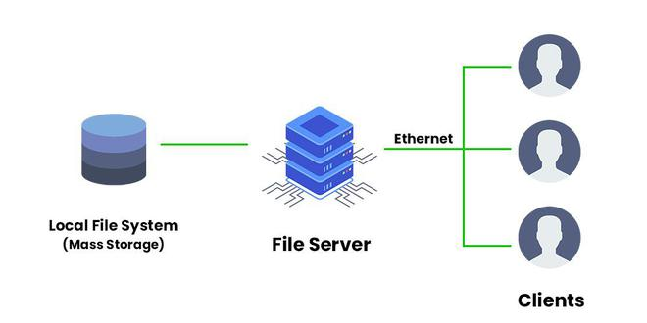

**Web Servers**

A web server is a computer that stores web server software and a website's component files. An example would be HTML documents, CSS stylesheets and images. Web servers must respond quickly and deliver large files, especially when transferring complex multimedia objects like images or video clips. Web servers are responsible for maintaining communication with an internal database server and will need to be placed into a DMZ, which provides an extra layer of security. The types of web servers we will need are Apache HTTP Server, Nginx, and Microsoft’s IIS.

**Requirements:**

Hardware Requirements for Web Servers

|  |  |  |
| --- | --- | --- |
| **Processor** | **HDD** | **RAM** |
| 2 x 1,6 GHz CPU | 1x 40 GB of free space or more is recommended for the web shop data.  1x 40 GB of free space or more is recommended for the software that is listed in the software requirements. | 3,5 GB RAM |

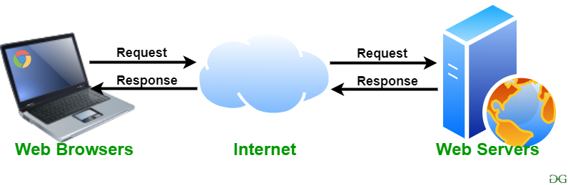

**Application Server**

An application server is a server that hosts applications or software that delivers a business application through a communication protocol. It is system software that resides between the operating system on one side, the external resources (such as a database management system [DBMS], communications and Internet services) on another side and the users’ applications on the third side.

We will use autocal which is a software suite that consists of a Windows application with a local database.

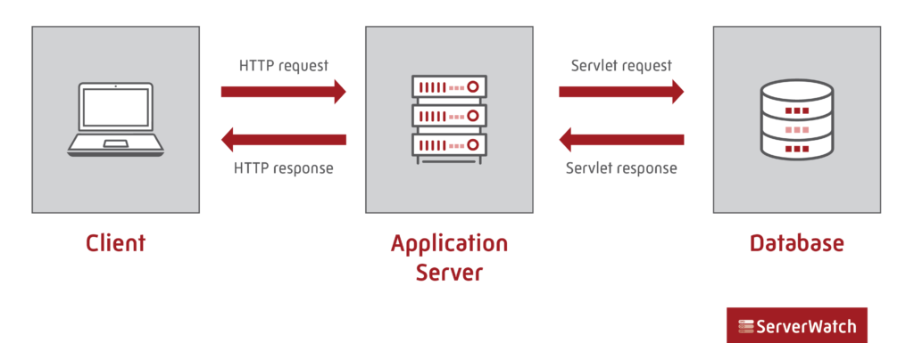

**Mail Server**

A mail server also known as a mail transfer agent, or MTA; mail transport agent; mail router; or internet mailer is an application that receives incoming email from local users and remote senders and forwards outgoing messages for delivery. The mail server will also be placed in the DMZ, to protect the hosts most vulnerable to attack.

**Requirements:**

Email Server System requirements

|  |  |  |  |
| --- | --- | --- | --- |
| **Users** | **Processor** | **RAM** | **Hard Drives** |
| 2500+ | 3.5 GHz Processor or higher with at least 8 cores | 32 GB | RAID 1 Array (System Drive) + RAID 10 Array (Mail Storage) + RAID 1 Array (Log Files) |

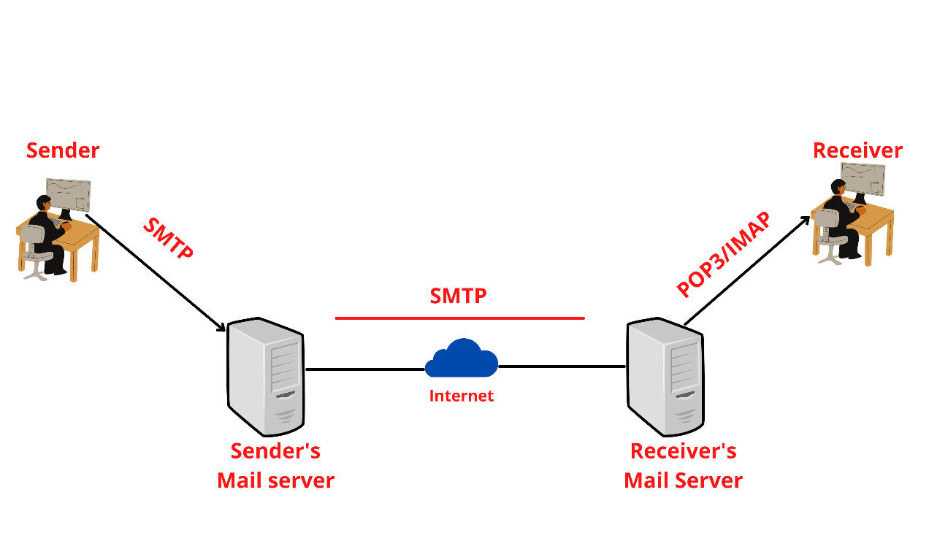

**Proxy Server**

A proxy server is an intermediary server that retrieves data from an Internet source, such as a webpage, on behalf of a user. They act as additional data security boundaries protecting users from malicious activity on the internet. The proxy server will reside between the user’s computer and the destination servers on the Internet.

**Requirements:** The Proxy servershould support GET, POST, and CONNECT methods. There should be connectivity between the Management Server and the proxy server. There should be connectivity between the proxy server and the resources that Management Server needs to access.

We will have a processor twice as fast as the minimum, as well as four times the minimum required memory — 2GHz and 2GB. 40GB of hard drive space. 32MB of Ram for each gigabyte of disk space set aside for caching.

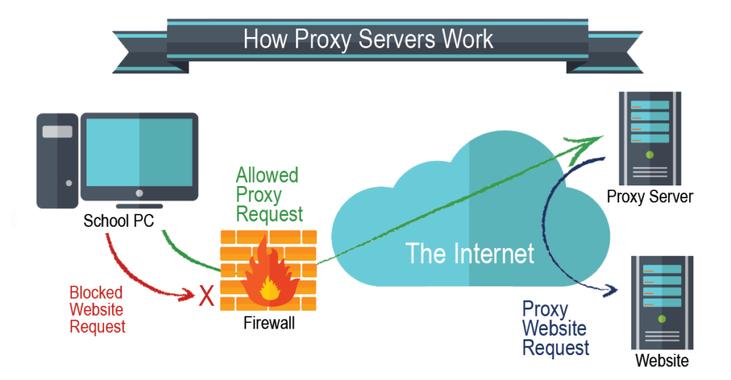

**FTP Server**

An FTP server is a computer program that is built to handle data transfer between computers. The server waits for clients to connect to it and issue commands that tell the server to upload, download, or list directories. The FTP protocol is the commands the FTP server uses to accomplish this

**Requirements:** For FTP to work, there needs to be a client and a server. The client connects to the service. The client and server communicate back and forth. The server must validate that the client has access to parts of the server it's trying to access, and then the client copies the files to the directories.

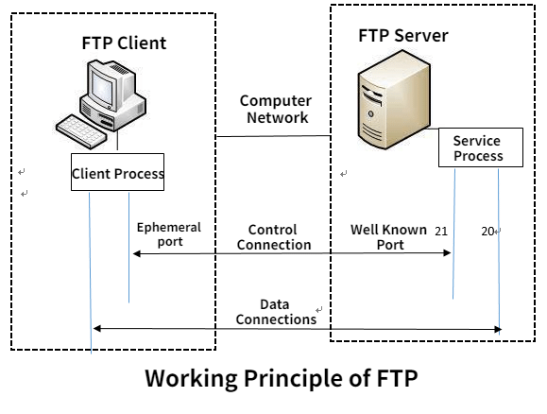

**DHCP Server**

Dynamic Host Configuration Protocol is an automatic configuration protocol used on IP networks. DHCP allows a computer to be configured automatically eliminating the need for intervention by a network administrator. It provides a central database for keeping track of computer’s IP allocation, this prevents two computers from accidentally being configured with the same IP address.

**Requirements:** Computers must be configured with specific IP information before they can communicate with other computers even on their own subnet. At a minimum they need IP Addresses and a Subnet mask.

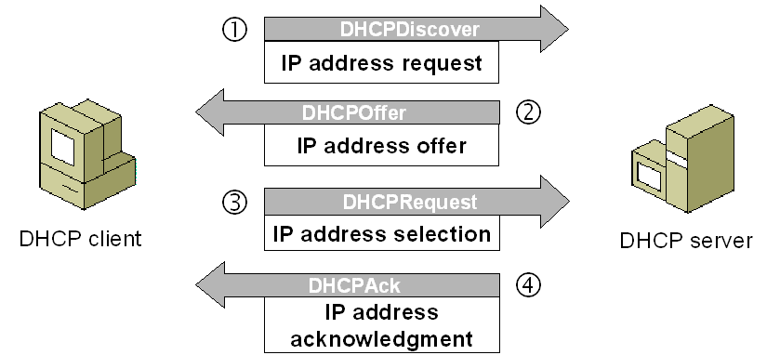

**Services**

**DNS**

DNS is a hierarchical distributed database and is one of the components of the internet about which severer security concerns now exist, without a great deal of solutions on the horizon. DNS was standardized in RFC1035 but a whole host of additional RFCs have been developed and the standard is in constant evolution. We will use Linux and BIND for public DNS and Active Directory integrated Windows for internal DNS.

**Requirements:** At minimum, we will need two DNS servers for each Internet domain we have. Relying on just one DNS server creates a single point of failure. If the primary server fails or is compromised by an attack, prospective visitors can no longer access the desired domain.

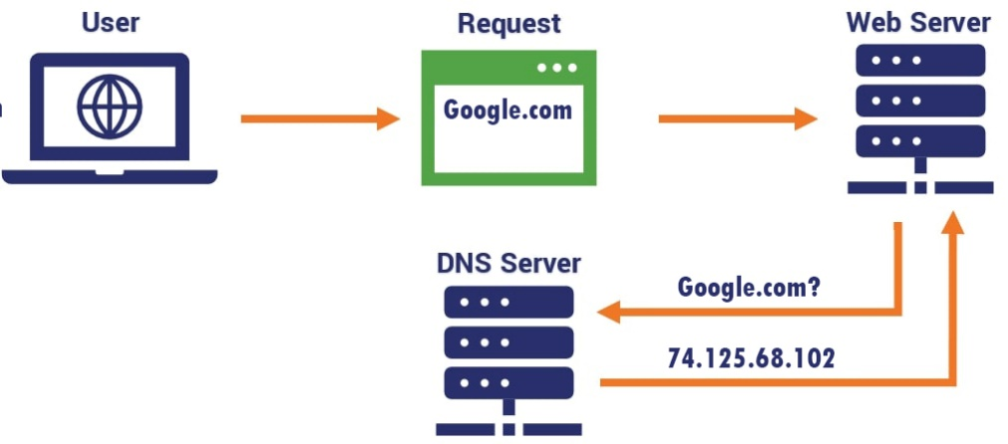

**NTP**

NTP is a protocol designed to synchronize the clocks of computers over a network to a common time base (usually UTC/GMT). NTP is one of the oldest protocols still in use. To be accurate, it calculates a round trip delay time and offset. NTP uses UDP Port 123 as standard.

**Requirements:** NTP is a UDP-based service. NTP servers use well-known port 123 to talk to each other and to NTP clients. NTP clients use random ports above 1023.

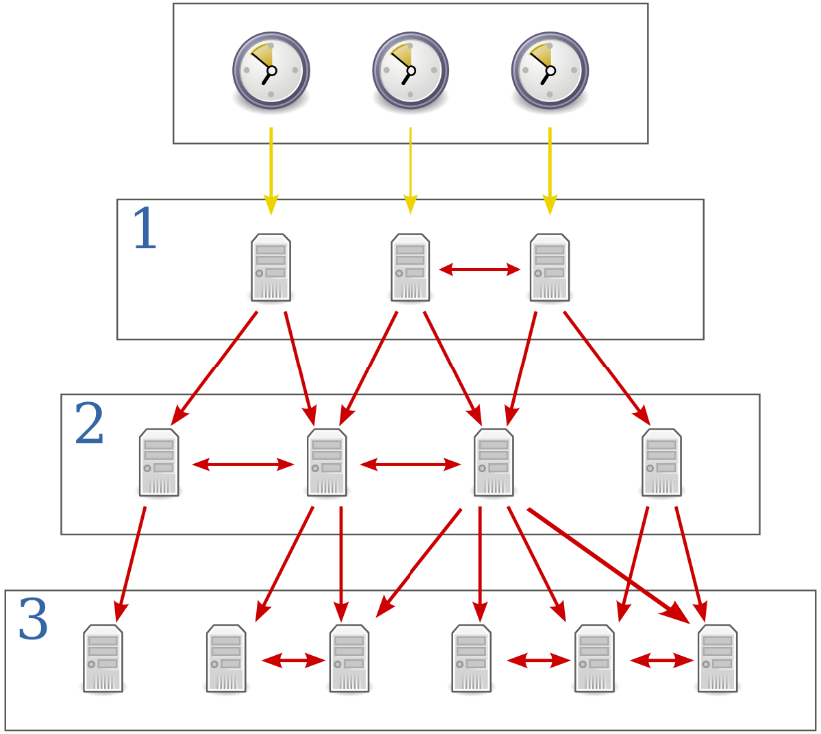

**SYSLOG Protocol**

The protocol provides a transport to allow a device to send event notification messages across IP networks to SYSLOG servers. The protocol is designed to transport these event messages from the generating device to the collector. The collector doesn't send back an acknowledgment of the receipt of the messages. Syslog is both a communications protocol and a set of programs and libraries.

**Requirements:** Syslog runs on UDP, where syslog servers listen to UDP port 514, and clients (sending log messages) use a port above 1023.

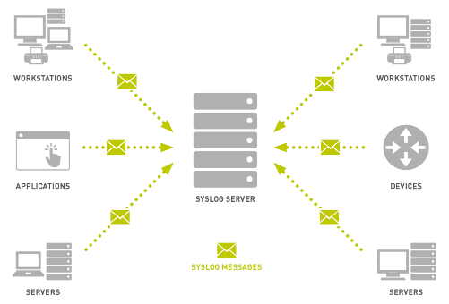

**TFTP**

Trivial File Transfer Protocol was designed as a cut-down version of FTP, with no authentication or security. It is used as a standard by most networking equipment to copy images and configurations up and down from equipment. When we set up our network for the first time, we will always need to apply a TFTP server to get and set configurations, firmware updates and software onto equipment.

**Requirements:** It can be implemented in a very small amount of memory and is very economic on resources.

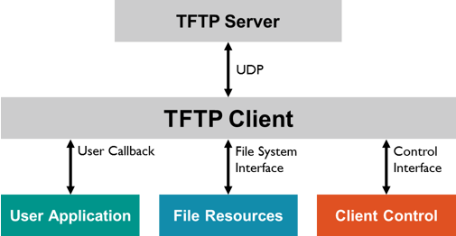

**SSH**

SSH allows secure access to a shell interface across public networks. It uses public key cryptography to authenticate the remote computer. SSH was developed in 1995 by Tatu Ylonen of the Helsinki University of Technology in response to a password sniffing attack.

**Requirements:** Remote command invocation through SSH, Public-private key authentication and Support for Batch Mode yes interaction, which is the ability to invoke the SSH command without interaction from an operator.

